Open a Linux terminal. If Linux is not installed, use an approved online Linux terminal or follow an instructor-provided setup guide

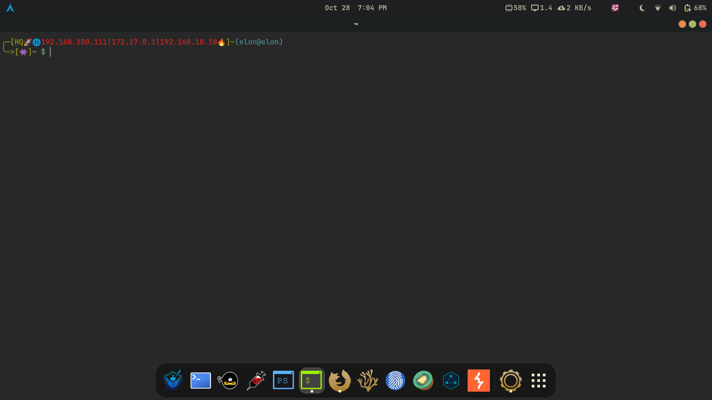
Practise the commands pwd, ls, cd, mkdir, touch, and cat

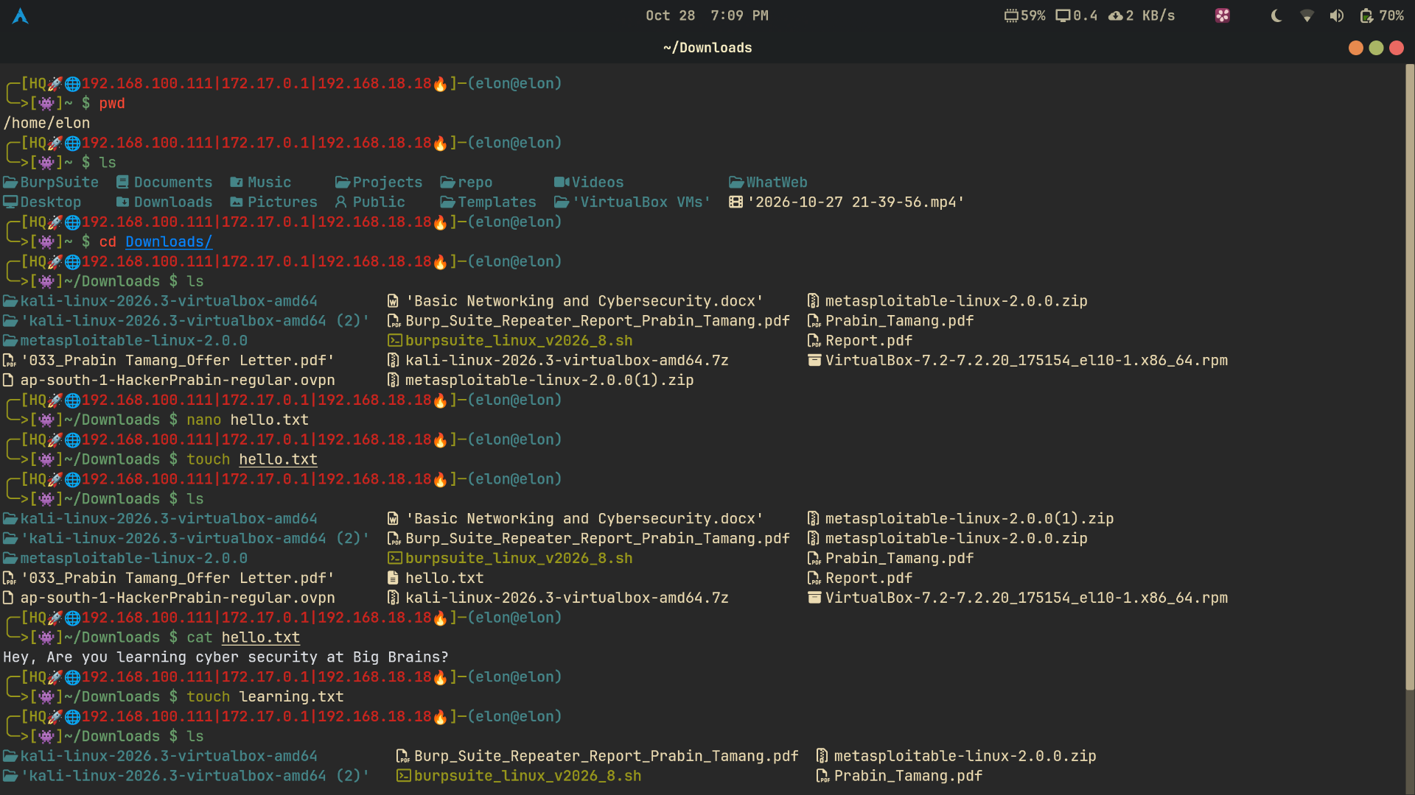

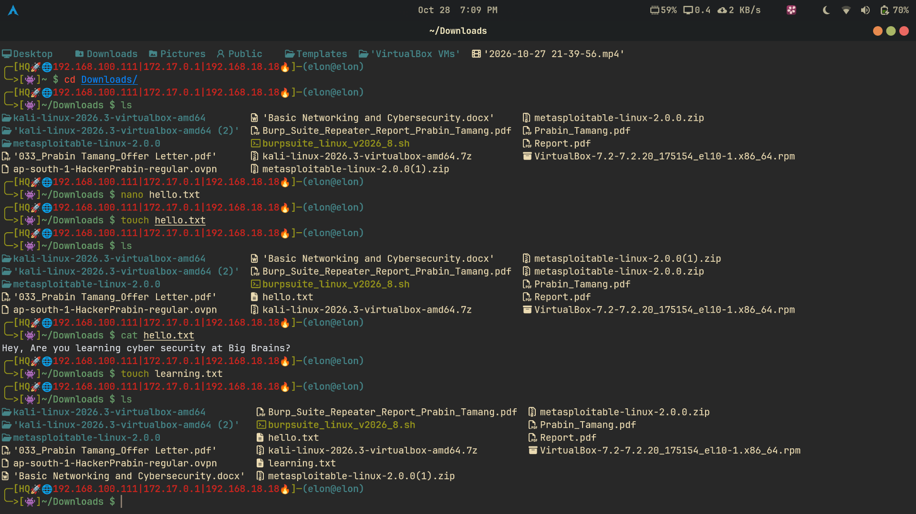
Create a folder named CyberSecurityPractice.

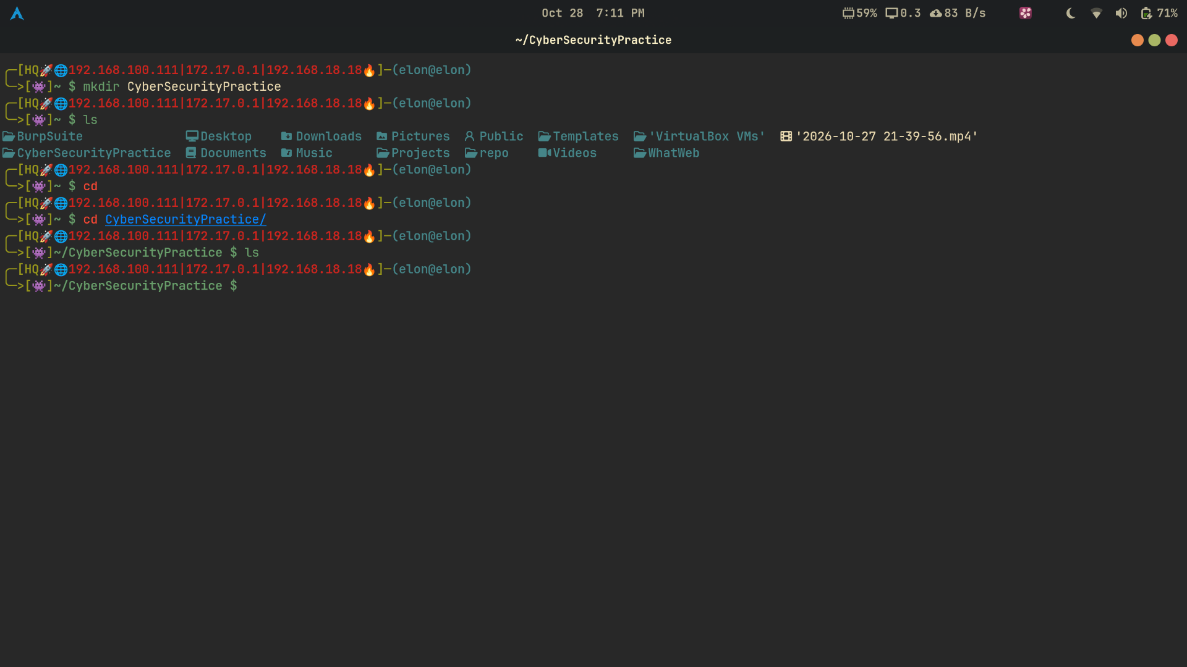
Inside that folder, create a text file named notes.txt and write five cybersecurity terms in it.

